**Do Donation Amounts and Frequency of Donations Decrease over Time?**

**Author(s)**

* Daniel Gutierrez
* Virginia Commonwealth University
* gutierrezd2@vcu.edu
* Information Systems
* Undergraduate
* Archana Ravishankar
* Virginia Commonwealth University
* ravishankara@vcu.edu
* Information Systems
* Undergraduate
* Yasmin Atassi
* Virginia Commonwealth University
* atassiy@vcu.edu
* Information Systems
* Undergraduate
* Jesse Asare-Addo
* Virginia Commonwealth University
* asareaddojk@vcu.edu
* Information Systems
* Undergraduate

**Faculty Advisor**

Joe Cipolla, Information Systems, jcipolla@vcu.edu

**Summary**

After conducting data analysis of the Hire Heroes, we recommend that Hire Heroes invest in finding new donors than those who have been donating over the years. Our recommendation should be the focal point in having new donors to start donating because over the years the donation does decrease by 50% percent. Our recommendation is for Hire Heroes to send out thank you gifts and messages to those who donate frequently to keep them donating constantly, to ensure don’t taper out after a year.

**Problem and Motivation**

The question we decided to address is, “Do our monthly donors give for a year and then lapse, or do they give over the course of a few years? And do our monthly donors who give more than one year increase their gift amount year over year?” These are great questions to address due to the moral obligation and pressure many people face to donate money to charities. We chose this question because we wanted to analyze the frequency and amount of donations to see which donors should receive gifts to thank them for their donations. According to the data provided from Hire Heroes, donations ranged from $0.90 to $8,523,500.00 over 12 years. We also chose this question because we were wondering why people donate the amounts they do over a certain period or just for one time. If Hire Heroes wants more donations, then they can look into sending their big/frequent donators a gift as an incentive to donate more. After choosing this question, we looked into the data to determine the behavior and trend of donors over the years to see if the donation amounts increased or decreased, both in frequency and amount.

**Approach**

Due to our problems from the previous section, our main focus was to increase donations by rewarding donors with thank you gifts. To do this, we first had to set a base donation amount that would warrant a gift to selected donors. It is impossible and not feasible to be able to thank all the thousands of donors. This led us to utilize the SalesForce_Account.xls and SalesForce_Opportunity.xls to figure out whether our monthly donors give for a year and then lapse, or if they give over a few years. Then made a focus on referencing columns headings with the Lifetime Donation History Amount and Number and total times donated. Then we moved on to cleaning the data to ensure that no dirty data was present, and our findings were based on clean data.

One of our issues was that we didn’t understand why people were donating less over the years and why some donors randomly donated a large amount just once. Without being able to directly contact the donors, we had no way of figuring or solving that issue. Another issue we were faced with was that we didn’t know whether to calculate our data by year vs by month to month. When we did month to month calculation, we were not able to calculate our data correctly because there were a lot of empty cells. Next, we attempted to calculate the data by trying quarters. So, in order for us to remove all the empty cells, and get a better data calculation, we ended up having to calculate by year. We plugged the data set into Tableau to create our various graphs. We displayed a chart showing whether donation amounts increase, broken down by donor type and the percentage increase by donor type.

**Tools and Analytics**

Choosing the right tools to analyze and clean the data was really fundamental as our goal is to get our results as accurate as we can. The main tools we used were Excel, Tableau Prep and Tableau Prep. First, we were given the data in CSV files for Mac and had to convert them to XLSX format to give us the option to format and formulas. When cleaning the data, we used in both Excel and Tableau prep, we used Excel for our first approach. We changed the FirstDonationDate and LastDonationDate from Month/Day/Year to just Year. By changing it to just Years it was easier to calculate how many people donated and how much they donated. In Reference 4 there were a total of 10 years of donation and the average amount of donation for the years.

After cleaning our data, we used Tableau desktop and used the data to connect both SalesForce Account and SalesForce Opportunity by using AccountID and ID to link donor types with the donation amount. Using the types of donors (Corporate Donors, Individual Donors, and Individual: Donors Advised Fund) where we got an accurate report for the amount of what each type of Donors had donated.

**Results**

When determining if donors lapse after a year is true, we compiled the types of donor data in Tableau and decided to use the line chart function to visualize the years of donation. As seen in References 1 and 2, most of the donations stayed the same over the years. 2013 was the one exception where there was an increase. We analyzed the data to determine whether our monthly donors who give more than one year increase their gift amount year over year.

From observing the data, the amount that donors, who donated more than one year, was actually reported to decrease over time. As seen in Reference 4, In year one, $9,760,925.60 was donated but fast forward to year five, only $2,556,307.78 was donated, which was a drastic drop in over 7 million dollars. It is also important to note that not only did the amount donated decrease, but also the number of donors themselves decreased throughout the seven years. As seen in Reference 5, we determined that over the years the number of donors decreased by about 50% for every year that passed. There were 16,858 donors in year 1,443 donors in year 2, 298 donors in year 3, 218 donors in year 4, 152 donors in year 5, 101 donors in year 6, 56 donors in year 7, and only 24 donors in year 8. Although we saw a consistent decrease in the amount that was donated, we did see a random peak in 2013 where over 15 million was donated for that one year. We have no evidence to explain this peak year, but a possible solution could be due to environmental factors. For example, a rise in the economy because when the economy is doing well, people tend to be more inclined to spend money.

**References**

Reference 1: Do Donations Increase?

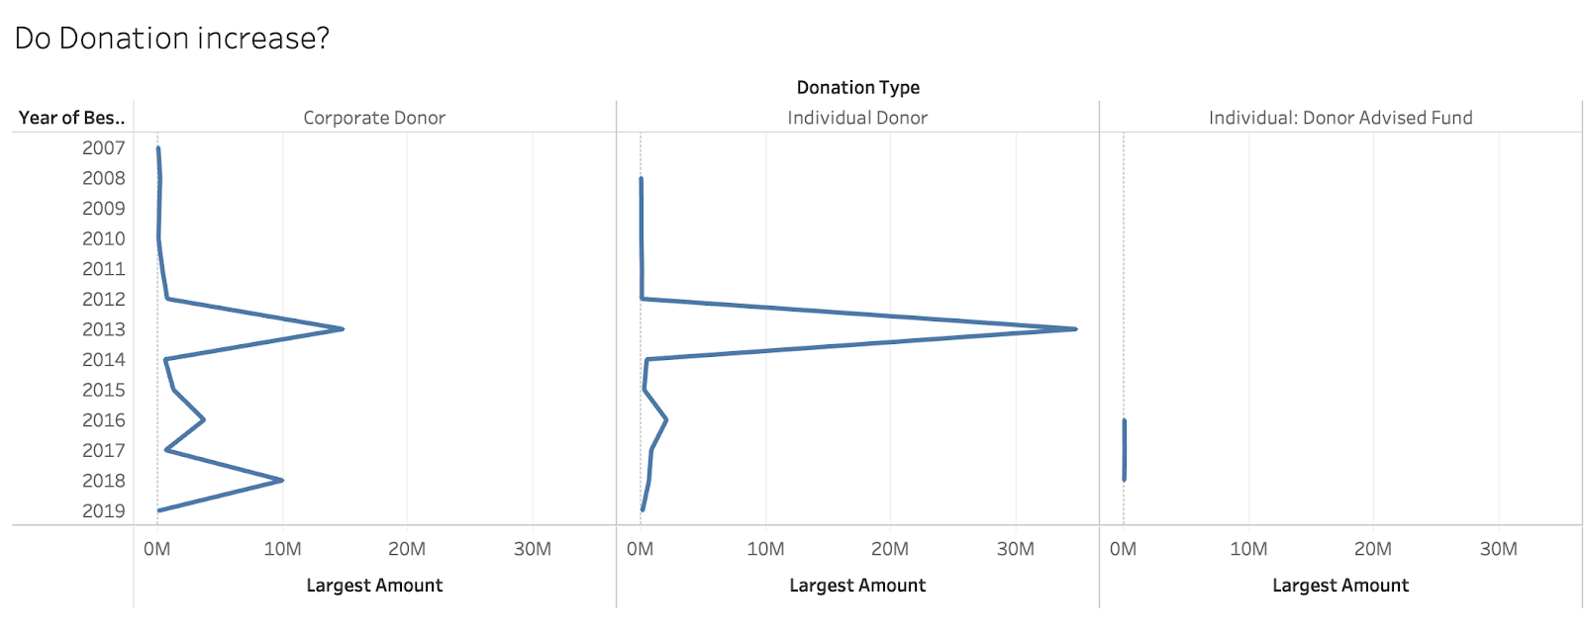

Reference 2: What are the percentage increase or decrease?

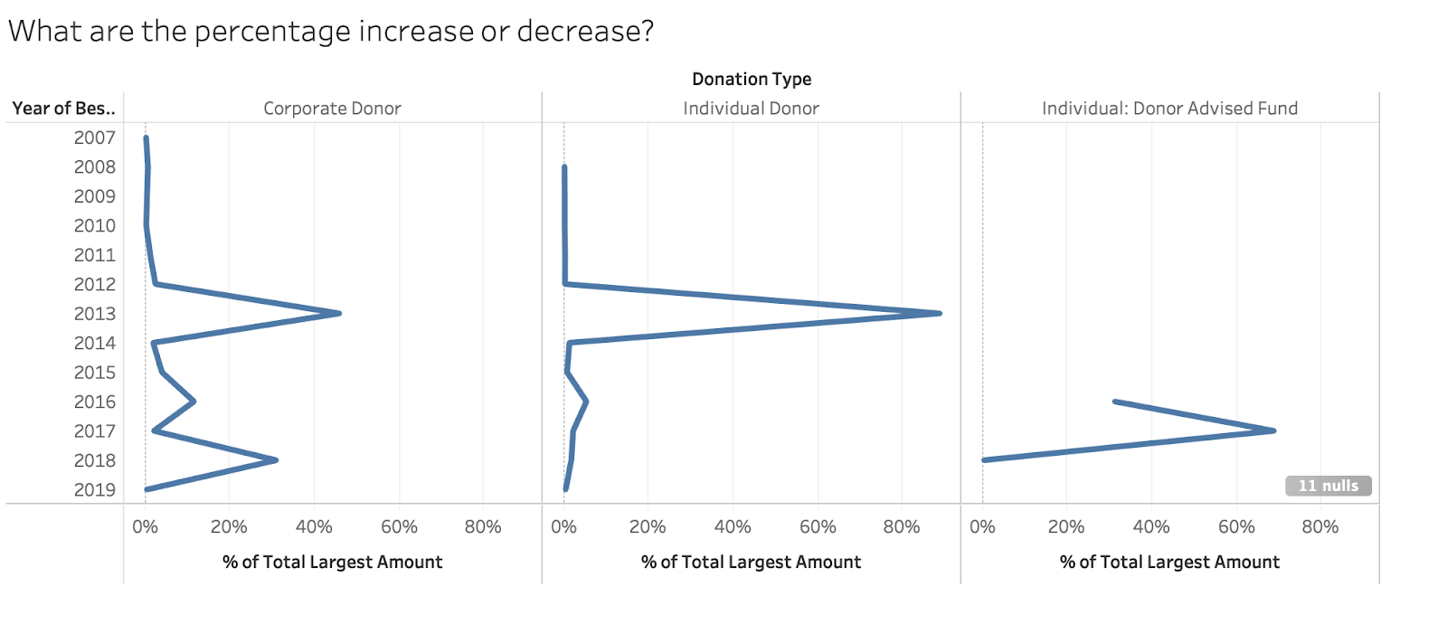

Reference 3: Percentage of monthly donors that increase after a year

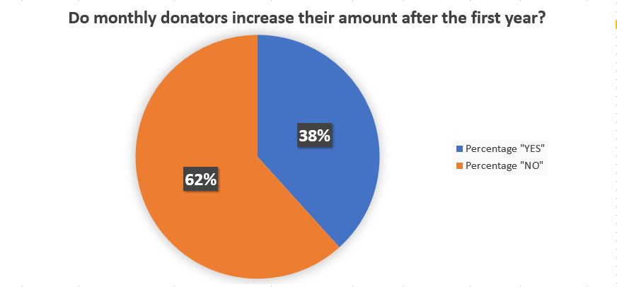

Reference 4: Dollar amount of donations each year

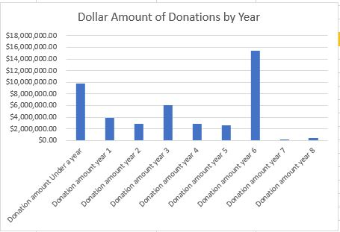

Reference 5: Number of donors by year

